CONTENTS
SL.NO | particulars | PAGE.NO
1 | Abstract | 2
2 | System Specifications | 3
3 | Introduction to openGL | 4
5 | Implementation | 7
6 | Interaction | 9
7 | Source Code | 10
8 | Output | 27
9 | Conclusion | 29
10 | Bibliography | 30

Abstract

- Main aim of this Mini Project is to show the simulation of a rocket launch.
- illustrate the concepts and usage of pre-built functions in OpenGL.
- When the rocket has completely exhausted is fuel from adjoining tanks, then the extra weight is lost by disconnecting them.
- When the final capsule reached the orbiting location the last part is also disconnected and the satellite is placed in orbit.
- We have used input device keyboard to interact with the program

System specifications

- SOFTWARE REQUIREMENTS :

- MICROSOFT VISUAL C++
- OPENGL

- HARDWARE REQUIREMENT :

- GRAPHICS SYSTEM,
- Pentium P4 with 256 of Ram(Min)

Introduction to openGL
As a software interface for graphics hardware, OpenGL's main purpose is to render two- and three-dimensional objects into a frame buffer.
These objects are described as sequences of vertices or pixels.
OpenGL performs several processing steps on this data to convert it to pixels to form the final desired image in the frame buffer.

OpenGL Fundamentals
This section explains some of the concepts inherent in OpenGL.

Primitives and Commands
OpenGL draws primitives—points, line segments, or polygons—subject to several selectable modes.
You can control modes independently of each other; that is, setting one mode doesn't affect whether other modes are set .Primitives are specified, modes are set, and other OpenGL operations are described by issuing commands in the form of function calls.
Primitives are defined by a group of one or more vertices. A vertex defines a point, an endpoint of a line, or a corner of a polygon where two edges meet. Data is associated with a vertex, and each vertex and its associated data are processed independently, in order, and in the same way. The type of clipping depends on which primitive the group of vertices represents.
Commands are always processed in the order in which they are received, although there may be an indeterminate delay before a command takes effect. This means that each primitive is drawn completely before any subsequent command takes effect. It also means that state-querying commands return data that's consistent with complete execution of all previously issued OpenGL commands.

Basic OpenGL Operation
The figure shown below gives an abstract, high-level block diagram of how OpenGL processes data. In the diagram, commands enter from the left and proceed through what can be thought of as a processing pipeline. Some commands specify geometric objects to be drawn, and others control how the objects are handled during the various processing stages.
Figure . OpenGL Block Diagram

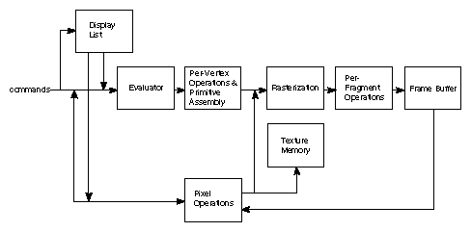

As shown by the first block in the diagram, rather than having all commands proceed immediately through the pipeline, you can choose to accumulate some of them in a display list for processing at a later time.
Rasterization produces a series of frame buffer addresses and associated values using a two-dimensional description of a point, line segment, or polygon.
Each fragment so produced is fed into the last stage,
per-fragment operations, which performs the final operations on the data before it's stored as pixels in the frame buffer. These operations include conditional updates to the frame buffer based on incoming and previously stored z-value s (for z-buffering) and blending of incoming pixel colors with stored colors, as well as masking and other logical operations on pixel values.
All elements of OpenGL state, including the contents of the texture memory and even of the frame buffer, can be obtained by an OpenGL application.

Implementation
This program is implemented using various openGL functions which are
shown below.
Various functions used in this program.
- glutInit() : interaction between the windowing system and OPENGL is initiated

- glutInitDisplayMode() : used when double buffering is required and depth information is required

- glutCreateWindow() : this opens the OPENGL window and displays the title at top of the window

- glutInitWindowSize() : specifies the size of the window

- glutInitWindowPosition() : specifies the position of the window in screen co-ordinates

- glutKeyboardFunc() : handles normal ascii symbols

- glutSpecialFunc() : handles special keyboard keys

- glutReshapeFunc() : sets up the callback function for reshaping the window

- glutIdleFunc() : this handles the processing of the background

- glutDisplayFunc() : this handles redrawing of the window

- glutMainLoop() : this starts the main loop, it never returns

- glViewport() : used to set up the viewport

- glVertex3fv() : used to set up the points or vertices in three dimensions

- glColor3fv() : used to render color to faces

- glFlush() : used to flush the pipeline

- glutPostRedisplay() : used to trigger an automatic redrawal of the object

- glMatrixMode() : used to set up the required mode of the matrix

- glLoadIdentity() : used to load or initialize to the identity matrix

- glTranslatef() : used to translate or move the rotation centre from one point to another in three dimensions

- glRotatef() : used to rotate an object through a specified rotation angle

Interaction with program
- This program includes interaction through keyboard.

- S → Start the Project
- Use keys A,D,W,S to control the moment of PacMan.
- Q-> Quit

Source Code

#include <windows.h>
#include<string.h>
#include<stdarg.h>
#include<stdio.h>
#include <glut.h>
static double x=0.0,x1=0.0,y1=0.1,z1=0.0,a1=0,y2=0,z2=0;
static double move=-60;
static bool seperate=false;

void
stroke_output(GLfloat x, GLfloat y, char *format,...)
{
va_list args;
char buffer[200], *p;
va_start(args, format);
vsprintf(buffer, format, args);
va_end(args);
glPushMatrix();
glTranslatef(-2.5, y, 0);
glScaled(0.003, 0.005, 0.005);
for (p = buffer; *p; p++)
glutStrokeCharacter(GLUT_STROKE_ROMAN, *p);
glPopMatrix();
}

void satellite(){

glPushMatrix();

//Core

glPushMatrix();
glColor3f(1,1,0);
glTranslatef(0,2,0);
glScaled(0.3,1,0.3);
glRotatef(90,1,0,0);
if(x<=6)
glutSolidTorus(0.5,1,30,30);
else
glutSolidCube(1);
glPopMatrix();

// Solar Panel

glPushMatrix();
glColor3f(0.2,0.2,0.2);
glTranslatef(1,2,0);

if(x>=6){
glScaled(4,1.5,0.1);
}
else
glScaled(0,0,0);

glRotatef(-20,1,0,0);
glutSolidCube(0.5);
glPopMatrix();

glPushMatrix();
glColor3f(0.2,0.2,0.2);
glTranslatef(-1,2,0);
if(x>=6){
glScaled(4,1.5,0.1);
}
else
glScaled(0,0,0);
glRotatef(-20,1,0,0);
glutSolidCube(0.5);
glPopMatrix();

glPopMatrix();
}

void rocket(){

// Main top cone
glPushMatrix();
if(x>=5.5){
glTranslatef(z2,-z2,z2);
glRotatef(a1,0,1,1);
}
glPushMatrix();
glTranslatef(0,2.5,0);
glColor3f(0,0,1);
glScaled(2.2 ,1.5,2.2);
glRotatef(270,1,0,0);
glutSolidCone(0.2,1,30,30);

glPopMatrix();

glPopMatrix();

// Satelitte container
glPushMatrix();
if(x>=6.8){

glTranslatef(2,0,0);
glRotatef(x*40,0,1,0);

}
satellite();
glPopMatrix();
glPushMatrix();
if(x>=5){
glTranslatef(0,y2,y2);
glRotatef(a1,0,1,1);

}

glPushMatrix();
glColor3f(1,1,1);
glTranslatef(0,0.0,0);
glScaled(0.3,4.3,0.3);
glRotatef(90,1,0,0);
glutSolidTorus(0.5,1,30,30);
glPopMatrix();

glPushMatrix();
glTranslatef(0,-2.2,0);
glColor3f(0,0,1);
glScaled(3,1.5,3);
glRotatef(270,1,0,0);
glutSolidCone(0.2,1,30,30);
glPopMatrix();

glPopMatrix();

// RightSide rocket
glPushMatrix();
glTranslatef(x1,-y1,z1);
glRotatef(a1,0,1,1);

glPushMatrix();
glTranslatef(0.7,1,0);
glColor3f(0,0,1);
glScaled(1.5 ,1,1.5);
glRotatef(270,1,0,0);
glutSolidCone(0.2,1,30,30);
glPopMatrix();

glPushMatrix();
glTranslatef(0.7,-0.2,0);
glColor3f(0,1,1);
glScaled(0.2,6.5,0.2);
glRotatef(90,1,0,0);
glutSolidTorus(0.2,1,30,30);
glPopMatrix();

glPushMatrix();
glTranslatef(0.7,-2.0,0);
glColor3f(0,0,1);
glScaled(1.5,1,1.5);
glRotatef(270,1,0,0);
glutSolidCone(0.2,1,30,30);
glPopMatrix();

glPopMatrix();

// LeftSide rocket

glPushMatrix();
glTranslatef(-x1,-y1,-z1);
glRotatef(-a1,0,1,1);

glPushMatrix();
glTranslatef(-0.7,1,0);
glColor3f(0,0,1);
glScaled(1.5 ,1,1.5);
glRotatef(270,1,0,0);
glutSolidCone(0.2,1,30,30);
glPopMatrix();

glPushMatrix();
glTranslatef(-0.7,-0.2,0);
glColor3f(0,1,1);
glScaled(0.2,6.5,0.2);
glRotatef(90,1,0,0);
glutSolidTorus(0.2,1,30,30);
glPopMatrix();

glPushMatrix();
glTranslatef(-0.7,-2.0,0);
glColor3f(0,0,1);
glScaled(1.5,1,1.5);
glRotatef(270,1,0,0);
glutSolidCone(0.2,1,30,30);
glPopMatrix();

//booster
/*
glPushMatrix();
glTranslatef(2,0,0);
glColor3f(1,1,0);
glBegin(GL_POLYGON);

glVertex3f(0,0,0);
glVertex3f(1,0,0);
glVertex3f(0.8,-1,0);
glVertex3f(0,0,0);

glEnd();

glPopMatrix();

*/
glPopMatrix();

}

void stars(){

for(float s1=5;s1<=100; s1+=0.4){
for(float s2=-6;s2<=6;s2+=0.5){

glPushMatrix();
glBegin(GL_POINTS);
glVertex3f(s2,s1,0);

glEnd();
glPopMatrix();

}

}

for(float s3=5.2;s3<=100; s3+=0.3){
for(float s4=-6.2;s4<=6;s4+=0.3){
glPushMatrix();
glBegin(GL_POINTS);
glVertex3f(s4,s3,0);
glEnd();

glPopMatrix();

}

}

}

// Draw rocket

void rocket(double ang)
{
glClear(GL_COLOR_BUFFER_BIT | GL_DEPTH_BUFFER_BIT);
glLoadIdentity();
glTranslatef(0.0f,0.0f,-13.0f);
//glRotatef(ang,0.0f,1.0f,0.0f);

glPushMatrix();

if(ang<=2){
glRotatef(ang*30,1,0,0);
glTranslatef(0,-2+ang,0);
}
else{
glRotatef(60,1,0,0);
glTranslatef(0,0,0);
}
glScaled(0.5,0.5,0.5);
rocket();
glPopMatrix();

//Earth

glPushMatrix();
glColor3f(0,0,1);
if(x>=6.5){
glTranslatef(0,-18,-95);
glRotatef(10*x,0,1,0);

}else{
glTranslatef(0,-10-x,-10-15*x);
}

glutSolidSphere(10,100,100);
glPopMatrix();

// Create Stars
glPushMatrix();
glColor3f(1,1,1);
glTranslatef(0,-ang,0);
stars();
glPopMatrix();

glFlush();
glutSwapBuffers();
}

void p()
{

x+=0.01;

if(x>=3){
x1+=0.1;
y1+=0.1;
z1+=0.01;
a1+=3;
}

if(x>5){
y2-=0.1;

}

if(x>5.5){
z2+=0.1;
}

rocket(x);

}

void doInit()
{

/* Background and foreground color */
glClearColor(0.0,0.0,0.0,0);
glViewport(0,0,640,480);

/* Select the projection matrix and reset it then
setup our view perspective */

glMatrixMode(GL_PROJECTION);
glLoadIdentity();
gluPerspective(30.0f,(GLfloat)640/(GLfloat)480,0.1f,200.0f);

/* Select the modelview matrix, which we alter with rotatef() */
glMatrixMode(GL_MODELVIEW);
glLoadIdentity();
glClearDepth(2.0f);
glEnable(GL_DEPTH_TEST);
glDepthFunc(GL_LEQUAL);
}

void display()
{

glClear(GL_COLOR_BUFFER_BIT | GL_DEPTH_BUFFER_BIT);
glLoadIdentity();
glTranslatef(0.0f,0.0f,-13.0f);

stroke_output(-2.0, 1.7, "p/P-->Launch the` Rocket");

GLfloat mat_ambient[]={0.0f,1.0f,2.0f,1.0f};
GLfloat mat_diffuse[]={0.0f,1.5f,.5f,1.0f};
GLfloat mat_specular[]={5.0f,1.0f,1.0f,1.0f};
GLfloat mat_shininess[]={50.0f};
glMaterialfv(GL_FRONT,GL_AMBIENT,mat_ambient);
glMaterialfv(GL_FRONT,GL_DIFFUSE,mat_diffuse);
glMaterialfv(GL_FRONT,GL_SPECULAR,mat_specular);
glMaterialfv(GL_FRONT,GL_SHININESS,mat_shininess);

GLfloat lightIntensity[]={1.7f,1.7f,1.7f,1.0f};
GLfloat light_position3[]={0.0f,5.0f,0.0f,0.0f};
glLightfv(GL_LIGHT0,GL_POSITION,light_position3);
glLightfv(GL_LIGHT0,GL_DIFFUSE,lightIntensity);

glEnable(GL_COLOR_MATERIAL);

glFlush();
glutSwapBuffers();

}

void menu(int id)
{
switch(id)
{

case 2:glutIdleFunc(p);
break;

case 5:exit(0);
break;

}
glFlush();
glutSwapBuffers();
glutPostRedisplay();
}

void mykey(unsigned char key,int x,int y)
{

if(key=='p')
{
glutIdleFunc(p);
}

if(key=='q'||key=='Q')
{
exit(0);
}

}

int main(int argc, char *argv[])
{
glutInit(&argc, argv);
glutInitDisplayMode(GLUT_DOUBLE|GLUT_RGB);
glutInitWindowSize(1000,480);
glutInitWindowPosition(0,0);
glutCreateWindow("rocket");
glutDisplayFunc(display);
glEnable(GL_LIGHTING);
glEnable(GL_LIGHT0);
glShadeModel(GL_SMOOTH);
glEnable(GL_DEPTH_TEST);
glEnable(GL_NORMALIZE);
glutKeyboardFunc(mykey);
glutCreateMenu(menu);
glutAddMenuEntry("Launch 'p'",1);

glutAddMenuEntry("Quit 'q'",5);
glutAttachMenu(GLUT_RIGHT_BUTTON);
doInit();
glutMainLoop();
return 0;
}
OUTPUT OF THE PROGRAM

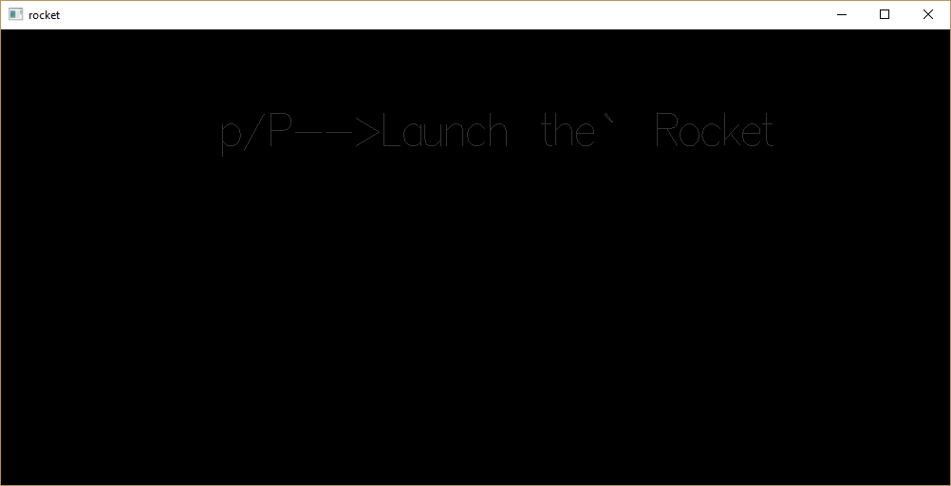
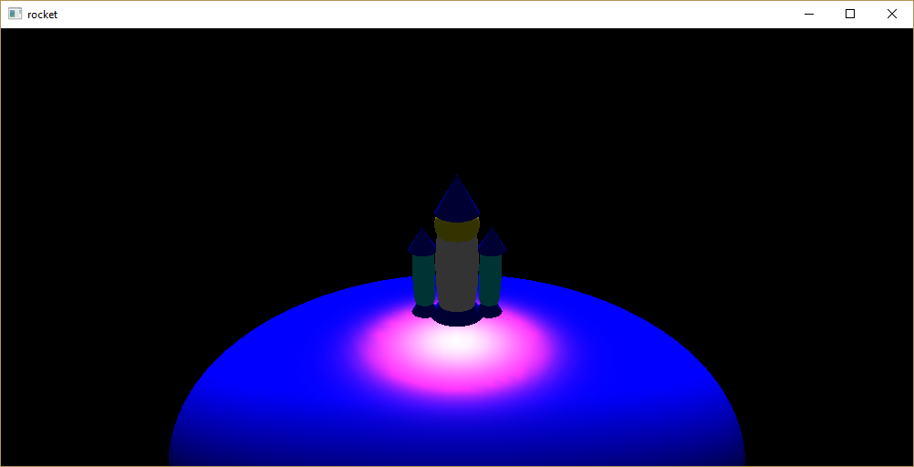
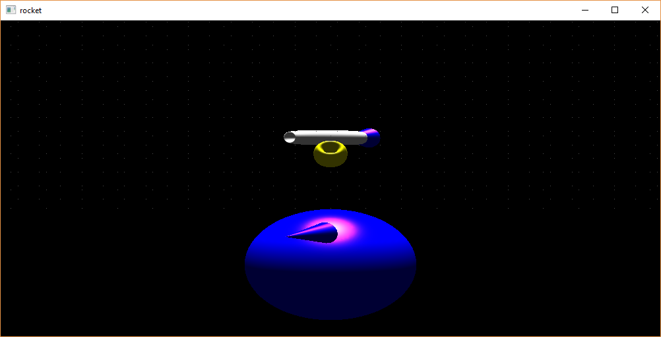
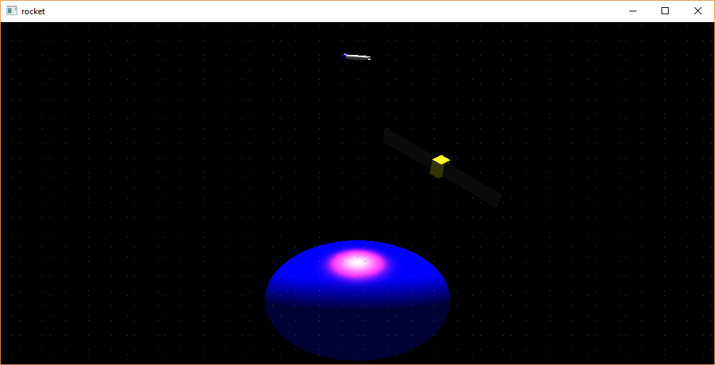

Conclusions

The project “Rocket Launch” clearly demonstrates the Simulation of a Rocket launch and putting the satellite in orbit.
Finally we conclude that this program clearly illustrate the Rocket launch by using OpenGL and pre-built objects and has been completed successfully and is ready to be demonstrated.

Bibliography
WE HAVE OBTAINED INFORMATION FROM MANY RESOURCES TO DESIGN AND IMPLEMENT OUR PROJECT SUCCESSIVELY. WE HAVE ACQUIRED MOST OF THE KNOWLEDGE FROM RELATED WEBSITES. THE FOLLOWING ARE SOME OF THE RESOURCES :

- TEXT BOOKS :
INTERACTIVE COMPUTER GRAPHICS A TOP-DOWN APPROACH
-By Edward Angel.

- COMPUTER GRAPHICS,PRINCIPLES & PRACTICES
- Foley van dam
- Feiner hughes

- WEB REFERENCES: http://jerome.jouvie.free.fr/OpenGl/Lessons/Lesson3.php
http://google.com
http://opengl.org

